Title: Online Bus Ticket Reservation System for Ethiopian Bus Stations

Chapter One

1.1 Introduction
Transportation plays a vital role in the economic and social development of Ethiopia. Bus transportation is the most widely used means of long-distance travel due to its affordability and accessibility. However, the ticket reservation process in most Ethiopian bus stations is still manual, time-consuming, and inefficient.
With the rapid growth of information technology and internet accessibility, there is a strong need to modernize the existing bus ticket reservation system. This project proposes the design and development of an Online Bus Ticket Reservation System that enables passengers to book bus tickets electronically from major bus stations such as Autobus Tera, Asko, Lamberet, and Zenebe Werk to various destinations across Ethiopia.

1.2. Background of the Study
Currently, many Ethiopian bus stations rely on manual ticket booking systems. Passengers must physically visit bus stations, stand in long queues, and depend on verbal information to know seat availability, departure times, and vehicle details. This traditional approach often leads to overcrowding, misinformation, ticket duplication, and customer dissatisfaction.
Globally, online reservation systems have proven effective in improving service delivery, operational efficiency, and customer convenience. Implementing a similar system tailored to Ethiopian bus transportation will help bridge the gap between modern technology and public transport services.

1.3. Problem Statement
The existing bus ticket reservation system in Ethiopia faces several challenges, including:
- Manual ticket booking that causes long waiting times
- Lack of real-time seat availability information
- Difficulty in tracking booked and unbooked seats
- Absence of electronic payment options
- No automatic receipt generation
- Inefficient management of vehicle and route information
These problems reduce service efficiency and negatively affect passenger satisfaction. Therefore, there is a need for a centralized online system that automates the ticket reservation process.

1.4. Objectives of the Study

1.4.1 General Objective
The general objective of this project is to design and develop an online bus ticket reservation system that improves ticket booking efficiency and passenger convenience for major bus stations in Ethiopia.

1.4.2 Specific Objectives
- To analyze the existing manual bus ticket reservation system
- To design an online system that displays available routes and vehicles
- To implement seat selection with occupied and free seat visualization
- To integrate electronic payment options such as CBE and Telebirr (conceptually)
- To generate electronic receipts for passengers
- To improve overall service delivery and management efficiency

1.5. Research Questions
This project seeks to answer the following questions:
- How can bus ticket booking be automated for Ethiopian bus stations?
- How can seat availability be displayed clearly to passengers?
- How can electronic payments be integrated into the reservation system?
- How can the system generate reliable booking verification receipts?

1.6. Scope of the Project
The scope of this project includes:
- Major bus stations such as Autobus Tera, Asko, Lamberet, and Zenebe Werk
- Online route and vehicle selection
- Seat availability and booking management
- Electronic payment processing (conceptual simulation)
- Receipt generation with travel and payment details
The project does not include GPS tracking or real-time traffic monitoring.

1.7. Significance of the Study
The proposed system will:
- Reduce congestion and waiting time at bus stations
- Improve transparency in seat allocation
- Enhance passenger convenience through online booking
- Support digital payment adoption in Ethiopia
- Serve as a foundation for future intelligent transport systems

1.8. Methodology
The project will follow a System Development Life Cycle (SDLC) approach, including:
- Requirement Analysis
- System Design
- Implementation Description
- Testing
- Documentation
Data will be collected through observation, interviews, and document analysis of existing bus reservation practices.

1.9. Tools and Technologies (Conceptual)
- Web-based application architecture
- Database-driven system
- Internet-enabled access
- Electronic payment platforms (CBE, Telebirr – conceptual)

1.10. Work Plan (Summary)
Activity | Duration
Proposal Preparation | 2 weeks
Requirement Analysis | 2 weeks
System Design | 3 weeks
Documentation | 3 weeks
Final Submission | 2 weeks

- 11. Expected Outcomes
- A fully documented online bus ticket reservation system
- Improved understanding of system analysis and design
- Enhanced practical knowledge in software engineering

SOFTWARE REQUIREMENT SPECIFICATION (SRS)

1. Introduction

1.1 Purpose
This Software Requirement Specification (SRS) document describes the functional and non-functional requirements of the Online Bus Ticket Reservation System. The document is intended to provide a clear understanding of system behavior for developers, supervisors, and examiners.

1.2 Intended Audience
This document is intended for:
- Project advisor
- Computer Science department evaluators
- System designers and analysts
- Final year project assessors

1.3 Definitions, Acronyms, and Abbreviations
Term | Description
SRS | Software Requirement Specification
UI | User Interface
CBE | Commercial Bank of Ethiopia
SDLC | System Development Life Cycle

2. Overall Description

2.1 Product Perspective
The system is a standalone web-based application designed to replace the manual bus ticket reservation process. It provides online access to route selection, vehicle assignment, seat booking, and payment verification.

2.2 Product Functions
The system will:
- Allow passengers to select bus stations and destinations
- Display available vehicles and departure times
- Show seat availability (occupied/free)
- Enable electronic payment (conceptual)
- Generate booking receipts

2.3 User Classes and Characteristics
User | Description
Passenger | Books tickets and makes payments
Administrator | Manages stations, routes, and vehicles

2.4 Operating Environment
- Web browser (Chrome, Firefox)
- Internet-enabled devices
- Server-based system architecture

2.5 Design and Implementation Constraints
- Internet connectivity requirement
- Payment gateways are simulated
- System limited to defined bus stations

2.6 Assumptions and Dependencies
- Users have basic internet access
- Bus stations provide accurate vehicle data
- Payment platforms are accessible

3. Functional Requirements

3.1 Passenger/User/ Functional Requirements
ID | Requirement Description
FR1 | User registration and login system.
FR2 | Search for available routes (e.g., Asko → Nekemte).
FR3 | View available vehicles for the selected route.
FR4 | Display seat layout with occupied and unoccupied seats.
FR5 | Select preferred seat(s).
FR6 | Make payment through integrated gateways (CBE, Telebirr).
FR7 | Receive booking confirmation with receipt.
FR8 | Cancel booking before departure (optional).

3.2 Administrator Functional Requirements
ID | Requirement Description
FR9 | Admin login and authentication.
FR10 | Add or remove buses.
FR11 | Assign buses to routes.
FR12 | Monitor seat occupancy and bookings.
FR13 | Generate reports for bookings and revenue.

Payment Functional Requirements
ID | Requirement Description
FR14 | Integration with CBE and Telebirr API.
FR15 | Secure processing of payment transactions.
FR16 | Update booking status after successful payment.

Booking Functional Requirements
ID | Requirement Description
FR17 | Confirm seat availability before booking.
FR18 | Generate digital receipt with booking details, vehicle number, start time, and passenger information.

4. Non-Functional Requirements

4.1 Performance Requirements
- System shall respond within 3 seconds
- Seat availability shall update in real time

4.2 Security Requirements
- User authentication required
- Data shall be protected from unauthorized access

4.3 Usability Requirements
- Simple and user-friendly interface
- Clear seat visualization

4.4 Reliability Requirements
- System shall ensure seat booking consistency
- Payment verification must be accurate

5. System Constraints
- Limited to selected Ethiopian bus stations
- No real-time GPS tracking
- Payment integration is conceptual
Summer of Non-Functional Requirements
Category | Requirement
Security | Passwords must be encrypted; payment transactions must be secure (HTTPS).
Reliability | The system must prevent double booking of the same seat.
Performance | The system should handle up to 1000 concurrent users.
Usability | Mobile-friendly interface, easy navigation for passengers.
Scalability | Able to add more bus stations, routes, and vehicles in the future.
Availability | The system should be available 24/7 with minimal downtime.
Maintainability | Code should be modular and documented for easy updates.

6. External Interface Requirements

6.1 User Interface
- Web-based forms and buttons
- Seat layout visualization

6.2 Hardware Interface
- Standard web server and client devices

6.3 Software Interface
- Database management system
- Payment platform APIs (conceptual)

7. Future Enhancements
- Mobile application
- Real payment gateway integration
- GPS tracking for buses

CHAPTER TWO

Existing/Current/ System

2.1 Description of the Existing System
Currently, most bus stations in Ethiopia operate using a manual ticket reservation system. Passengers must physically visit the bus station to obtain travel information and purchase tickets.

2.2 Workflow of the Existing System
- Passenger arrives at the bus station
- Passenger asks for route and vehicle availability
- Ticket officer manually checks seat availability
- Passenger pays cash
- A paper ticket is issued

2.3 Problems of the Existing System
- Long queues and overcrowding
- Manual seat allocation errors
- No real-time seat availability
- Risk of lost or duplicated tickets
- Cash handling risks
- Poor customer experience

3. Proposed System Overview
The proposed Online Bus Ticket Reservation System automates ticket booking by allowing passengers to:
- Select bus stations and destinations online
- View available vehicles and seat layouts
- Choose free seats visually
- Pay electronically
- Receive digital booking receipts

4. Feasibility Study

4.1 Technical Feasibility
The system is technically feasible because:
- Web technologies are widely available
- Database systems can manage large data
- Ethiopian payment platforms support digital transactions

4.2 Economic Feasibility
The system reduces operational costs by:
- Minimizing paper-based tickets
- Reducing staffing requirements
- Improving resource utilization
The initial development cost is affordable within the scope of a university project.

4.3 Operational Feasibility
- Passengers benefit from convenience
- Administrators gain better control
- Training requirements are minimal

5. User Requirement Analysis

5.1 Passenger Requirements
- Easy route selection
- Clear seat availability
- Secure payment
- Booking confirmation receipt

5.2 Administrator Requirements
- Manage stations and routes
- Assign vehicles
- Monitor bookings

6. System Requirements Summary
The system must:
- Ensure seat booking accuracy
- Provide secure access
- Operate reliably under normal load

SYSTEM DESIGN DOCUMENT

1. Introduction
This document presents the design of the Online Bus Ticket Reservation System. The design phase transforms system requirements into a structured solution that defines system architecture, components, and interactions.

2. System Architecture
The system follows a three-tier architecture:
- Presentation Layer
  - Web-based user interface
  - Used by passengers and administrators
- Application Layer
  - Business logic processing
  - Seat allocation and booking control
  - Payment processing logic
- Data Layer
  - Centralized database
  - Stores users, routes, vehicles, seats, bookings, and payments
This architecture ensures scalability, security, and maintainability.

3. Database Design (Conceptual)
The database design is based on a relational model with the following entities:
- User
- Bus Station
- Route
- Vehicle
- Seat
- Booking
- Payment
Each entity has a unique identifier and maintains relationships through foreign keys to ensure data integrity.

4. UML Diagram Descriptions

4.1 Use Case Diagram
Actors:
- Passenger
- Administrator
Passenger Use Cases:
- Select Route
- View Vehicles
- Select Seat
- Make Payment
- Receive Receipt
Administrator Use Cases:
- Manage Bus Stations
- Manage Routes
- Register Vehicles
- View Bookings

4.2 Class Diagram
The system consists of classes such as:
- User
- BusStation
- Route
- Vehicle
- Seat
- Booking
- Payment
Each class contains attributes and methods relevant to its specific responsibilities, and relationships define the interactions among classes.

4.3 Sequence Diagram
The sequence diagram illustrates the interaction flow during ticket booking:
- Passenger selects route
- System displays vehicles
- Passenger selects seat
- Payment is processed
- Receipt is generated

4.4 Activity Diagram
The activity diagram represents the workflow of booking a ticket from route selection to receipt generation.

5. Interface Design Description

5.1 Passenger Interface
- Station selection page
- Route and vehicle listing page
- Seat layout visualization
- Payment page
- Receipt display page

5.2 Administrator Interface
- Dashboard
- Station management
- Route management
- Vehicle registration
- Booking monitoring

6. Design Considerations
- User-friendly layout
- Clear seat status indicators
- Secure data handling
- Modular design for future expansion

DATA FLOW DIAGRAM (DFD) & UML DIAGRAM EXPLANATION
This document explains the Data Flow Diagrams (DFD) and Unified Modeling Language (UML) diagrams used in the Online Bus Ticket Reservation System. These diagrams help visualize how data flows within the system and how different components interact.

2. Context Diagram

Description
The context diagram represents the system as a single process and shows its interaction with external entities.

External Entities
- Passenger
- Administrator
- Payment Service Provider (CBE, Telebirr – conceptual)

Data Flows
- Passenger sends booking request
- System returns booking confirmation and receipt
- Administrator sends management instructions
- Payment provider returns payment confirmation

3. Data Flow Diagram (DFD Level 0)

Description
DFD Level 0 decomposes the system into major processes:
- Manage User Requests
- Process Ticket Booking
- Handle Payment
- Generate Receipt

Data Stores
- User Database
- Booking Database
- Payment Database
This level provides a high-level overview of system operations.
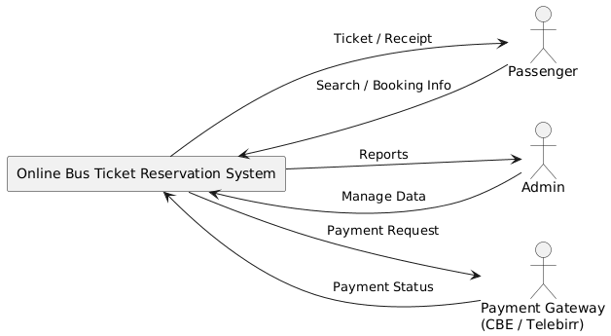

4. Data Flow Diagram (DFD Level 1)

Description
DFD Level 1 further breaks down the ticket booking process into detailed steps:
- Route Selection
- Vehicle Assignment
- Seat Availability Check
- Seat Reservation
- Payment Processing
- Receipt Generation
Each process exchanges data with relevant databases to ensure consistency.
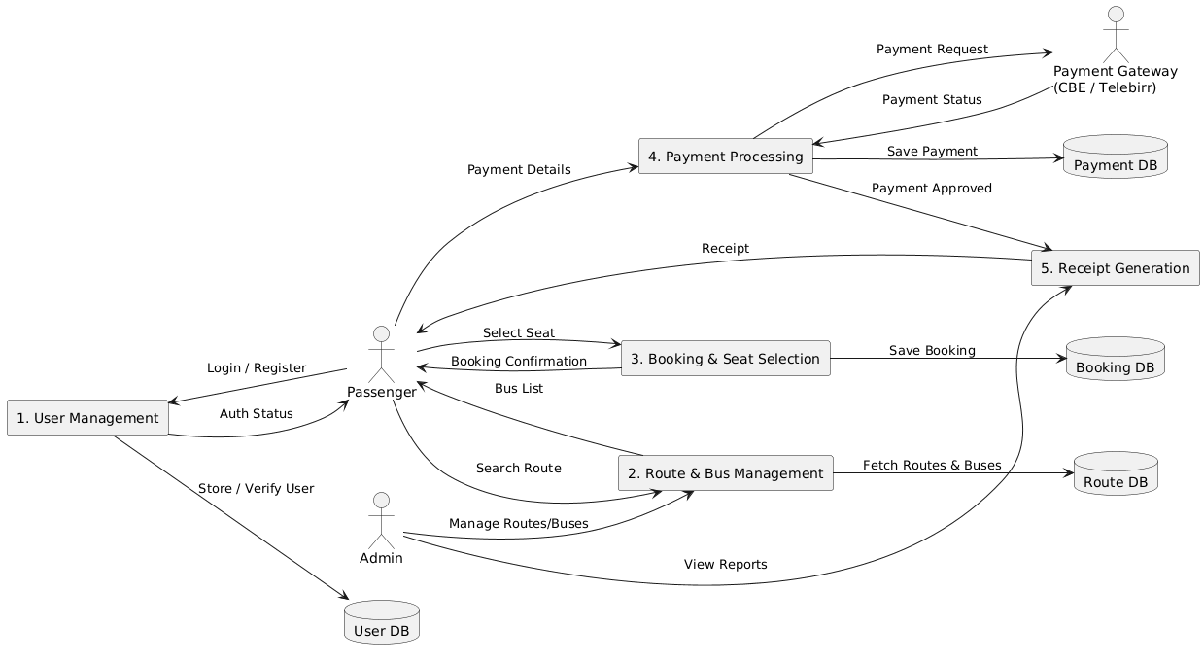

5. Use Case Diagram Explanation

Actors
- Passenger
- Administrator

Passenger Use Cases
- Select Bus Station
- Choose Route
- View Available Vehicles
- Select Seat
- Make Payment
- View Receipt

Administrator Use Cases
- Add Bus Stations
- Create Routes
- Register Vehicles
- Monitor Bookings
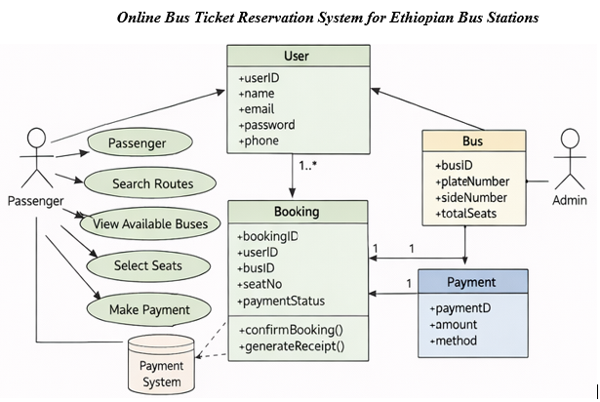

6. UML Sequence Diagram Explanation
The sequence diagram illustrates how objects interact over time during a ticket booking process:
- Passenger initiates booking
- System validates route and vehicle
- Seat availability is checked
- Payment request is sent
- Payment confirmation received
- Receipt is generated and sent to passenger
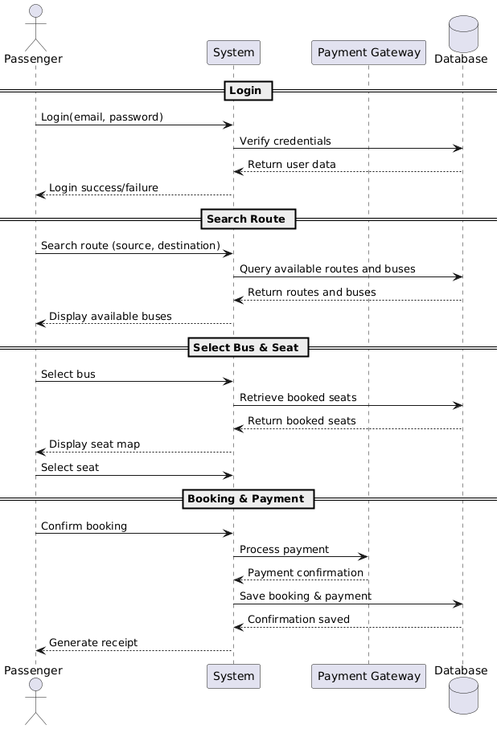

7. UML Class Diagram Explanation
The class diagram defines system structure and relationships:
- A BusStation can have many routes
- A Route connects two stations
- A Vehicle belongs to a route
- A Vehicle has multiple seats
- A Seat can be booked once
- A Booking links passenger, seat, and vehicle
- A Payment confirms the booking
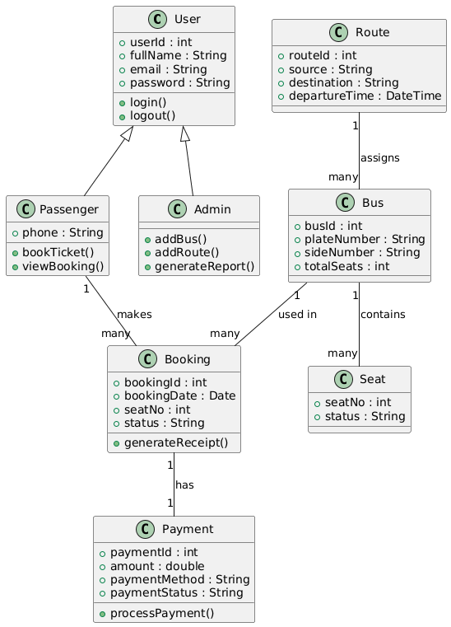

8. UML Activity Diagram Explanation
The activity diagram shows the workflow of the system:
- Start
- Select station and route
- Choose vehicle
- Select seat
- Make payment
- Generate receipt
- End

Activity Diagram (Passenger Booking Process)
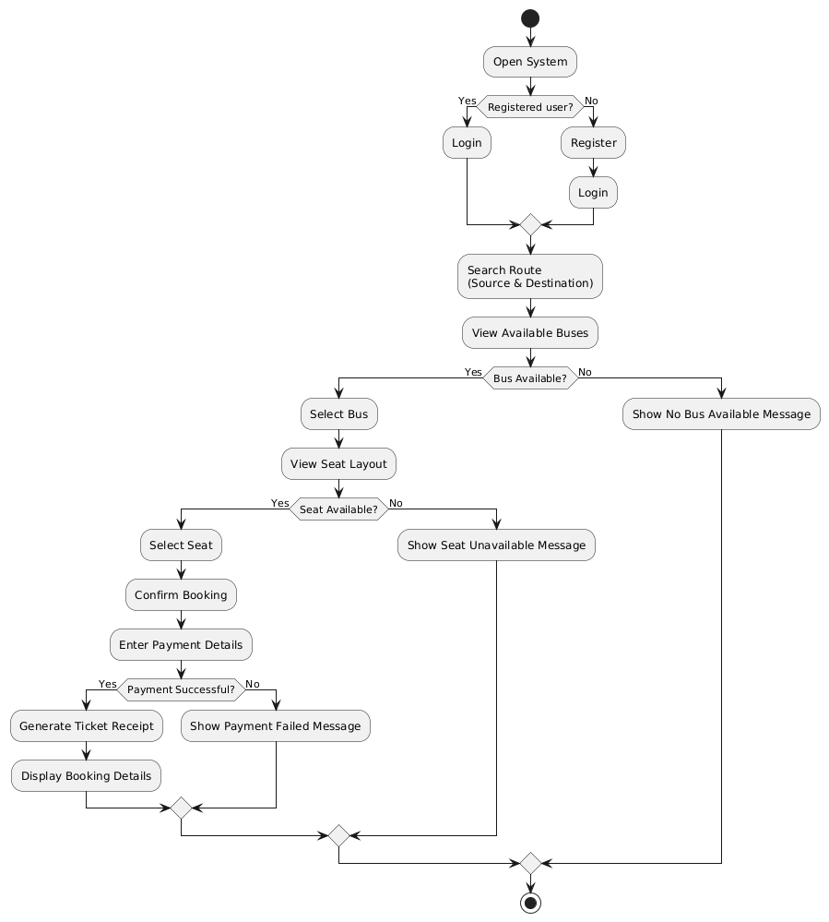
E-R Diagram (Entity–Relationship Diagram): is a conceptual database model that shows:
- What data the system stores (Entities)
- How the data items are related (Relationships)
- Key attributes of each entity and is a required mainly in the database design.

Purpose of the E-R Diagram in This System
The E-R diagram helps to:
- Design the database structure
- Avoid data redundancy
- Show relationships between passengers, buses, bookings, and payments
- Serve as a blueprint for SQL table creation
Main Entities in the Online Bus Ticket Reservation System

1️. User / Passenger
Represents people who book tickets.
Attributes:
- user_id (Primary Key)
- full_name
- email
- password
- phone_number

2️. Route
Represents travel paths between cities.
Attributes:
- route_id (Primary Key)
- source
- destination
- departure_time

3️. Bus
Represents vehicles assigned to routes.
Attributes:
- bus_id (Primary Key)
- plate_number
- side_number
- total_seats
- route_id (Foreign Key)

4️. Seat
Represents seats inside a bus.
Attributes:
- seat_no (Primary Key)
- status (Available / Booked)
- bus_id (Foreign Key)
5️. Booking
Represents a ticket reservation.
Attributes:
- booking_id (Primary Key)
- booking_date
- seat_no
- status
- user_id (Foreign Key)
- bus_id (Foreign Key)

6️. Payment
Represents payment information.
Attributes:
- payment_id (Primary Key)
- amount
- payment_method (CBE, Telebirr)
- payment_status
- booking_id (Foreign Key)
Relationships in the E-R Diagram
Relationship | Description | Type
User → Booking | A user can make many bookings | 1: M
Route → Bus | One route can have many buses | 1: M
Bus → Seat | One bus contains many seats | 1: M
Bus → Booking | One bus can have many bookings | 1: M
Booking → Payment | One booking has one payment | 1: 1

Simple Text Representation of ER Diagram
User ────< Booking >──── Bus ────< Seat
|
|
Payment

Route ────< Bus

Why the ER Diagram Is Important in this Project
- Mandatory for the database design section
- Required in System Design
- Helps examiners understand data flow & structure
- Used to generate SQL tables
- Aligns with UML Class Diagram

Generally, the E-R Diagram visually explains how passengers, routes, buses, seats, bookings, and payments are connected, making it a core component of your graduation project documentation.
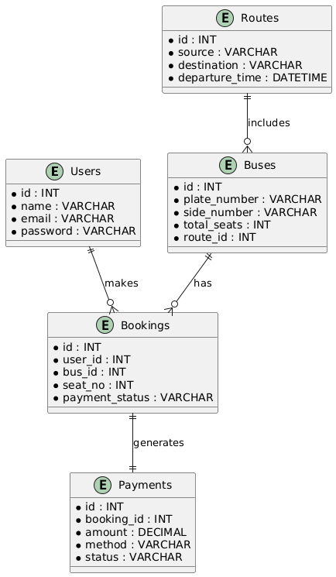

9. Importance of Diagrams
These diagrams:
- Improve system understanding
- Reduce implementation errors
- Help examiners visualize system logic
- Support effective communication among stakeholders

SYSTEM IMPLEMENTATION DESCRIPTION [no code here]

1. Introduction
This document outlines the conceptual implementation of the Online Bus Ticket Reservation System. It explains system modules, workflows, and interactions without including any source code, as required for academic documentation.

2. System Modules Description
The system is divided into several functional modules to ensure clarity, maintainability, and efficient operation.

2.1 Passenger Module
The Passenger Module allows users to book bus tickets online.
Functions of Passenger Module:
- Select bus station (Autobus Tera, Asko, Lamberet, Zenebe Werk)
- Choose destination (e.g., Asko → Nekemte)
- View available vehicles
- View seat layout (occupied and free seats)
- Select preferred seat
- Make payment
- Receive booking receipt
This module improves user convenience and reduces physical presence at bus stations.

2.2 Route and Vehicle Management Module
This module controls how routes and vehicles are assigned.
Key Features:
- Routes are predefined between stations
- Each route has assigned vehicles
- Vehicles include details such as:
  - Plate number
  - Departure time
  - Total seats
The system ensures that only vehicles assigned to a selected route are displayed.

2.3 Seat Management Module
The Seat Management Module ensures accurate seat booking.
Seat Handling Process:
- Each vehicle has a fixed number of seats
- Seats are categorized by number and side (left/right)
- Seats are marked as:
  - Available
  - Occupied
Once a seat is booked, the system automatically updates its status to prevent double booking.

2.4 Payment Module
The Payment Module handles passenger payments.
Supported Payment Methods (Conceptual):
- Commercial Bank of Ethiopia (CBE)
- Telebirr
Payment Workflow:
- Passenger selects payment method
- System processes payment request
- Payment confirmation is received
- Booking is validated
This module ensures transaction transparency and security.

2.5 Receipt Generation Module
After successful booking and payment, the system generates a digital receipt.
Receipt Information Includes:
- Passenger name
- Selected route
- Vehicle plate number
- Seat number and side
- Payment method
- Travel date and departure time
This receipt serves as proof of booking.

3. Booking Workflow Explanation
The booking process follows these steps:
- Passenger selects station and destination
- System displays available vehicles
- Passenger selects a vehicle
- System shows seat availability
- Passenger selects seat
- Payment is processed
- Receipt is generated

4. Data Handling and Integrity
- Each booking is uniquely identified
- Seat status is updated in real time
- Payment records are linked to bookings
- Data consistency is maintained through validation checks

5. Security Considerations
- User authentication is required
- Booking actions are validated
- Payment confirmation is verified
- Data access is restricted by user role

6. Implementation Benefits
- Reduced manual workload
- Improved accuracy in seat allocation
- Enhanced passenger satisfaction
- Better administrative control

SYSTEM TESTING AND TEST CASES

1. Introduction
System testing ensures that the Online Bus Ticket Reservation System meets functional and non-functional requirements. Testing ensures that the system operates correctly, reliably, and efficiently for both passengers and administrators.

2. Testing Strategy
The system will follow black-box testing techniques for functional verification and conceptual walkthroughs for non-functional aspects such as performance and usability.
Testing Levels:
- Unit Testing – Verify individual modules
- Integration Testing – Ensure modules interact correctly
- System Testing – Test the complete system
- User Acceptance Testing – Evaluate the system with sample users

3. Test Cases
The table below summarizes key test scenarios:
Test Case ID | Module | Description | Input | Expected Result
TC-01 | Passenger Module | Select bus station | Autobus Tera | List of available destinations displayed
TC-02 | Passenger Module | Select route | Asko → Nekemte | Available vehicles displayed
TC-03 | Passenger Module | Select seat | Seat 5 Right | Seat marked as booked; status updated
TC-04 | Payment Module | Make payment | CBE payment info | Payment confirmed; booking validated
TC-05 | Payment Module | Make payment | Telebirr payment info | Payment confirmed; booking validated
TC-06 | Receipt Module | Generate receipt | Booking complete | Digital receipt generated with all details
TC-07 | Admin Module | Add bus station | New station info | Station added successfully
TC-08 | Admin Module | Create route | Route info | Route registered successfully
TC-09 | Admin Module | Register vehicle | Vehicle info | Vehicle added; seats generated
TC-10 | Admin Module | View bookings | N/A | All bookings displayed with details

4. Non-Functional Testing

4.1 Performance Testing
- Response time under normal load < 3 seconds
- Seat availability updates in real time

4.2 Security Testing
- Verify role-based access
- Validate payment confirmation
- Ensure data privacy

4.3 Usability Testing
- User-friendly interface
- Seat layout visualization is clear
- Forms are easy to complete

5. Expected Testing Results
- Pass all functional test cases
- No duplicate seat bookings
- Accurate payment confirmation
- Proper receipt generation
- System meets usability and security standards

6. Importance for Defense
- Demonstrates that the system works correctly
- Shows adherence to SRS and design specifications
- Provides clear evidence for examiners

RESULTS, DISCUSSION, CONCLUSION & RECOMMENDATIONS

1. Introduction
This document presents the results achieved by the system, discusses its effectiveness, and provides final conclusions and recommendations for future work. It summarizes the outcomes of the Online Bus Ticket Reservation System project.

2. Results
The system successfully implements the following:
- Passenger Functions
  - Online selection of bus stations and destinations
  - Display of available vehicles
  - Seat selection with clear occupied/free visualization
  - Electronic payment simulation (CBE & Telebirr)
  - Generation of booking receipts with full details
- Administrator Functions
  - Management of bus stations, routes, and vehicles
  - Monitoring of all bookings
- System Performance
  - Fast response times (< 3 seconds)
  - Accurate seat availability updates
  - Secure access for passengers and administrators

3. Discussion
- Improved Efficiency: The online system eliminates long queues and reduces manual errors in seat allocation.
- Passenger Convenience: Users can book tickets remotely, view real-time seat availability, and receive digital receipts.
- Operational Control: Administrators can manage routes and vehicles effectively.
- Limitations:
  - Payment integration is conceptual; real transactions are not yet processed
  - GPS tracking and real-time traffic updates are not included
  - Limited to selected major bus stations

4. Conclusion
The Online Bus Ticket Reservation System for Ethiopian bus stations fulfills its objectives:
- Automates ticket booking
- Provides accurate seat allocation
- Simulates electronic payment and receipt generation
- Enhances both passenger experience and administrative control
This project demonstrates the successful application of software engineering principles, including system analysis, design, implementation, and testing.

5. Recommendations
For future improvements:
- Integrate real-time payment gateways to process actual transactions
- Develop a mobile application for wider accessibility
- Implement GPS tracking to inform passengers about vehicle location
- Include analytics and reporting features for administrators
- Expand the system to all Ethiopian bus stations

